Tyrone Minor, M.A., M.Ed. Bio

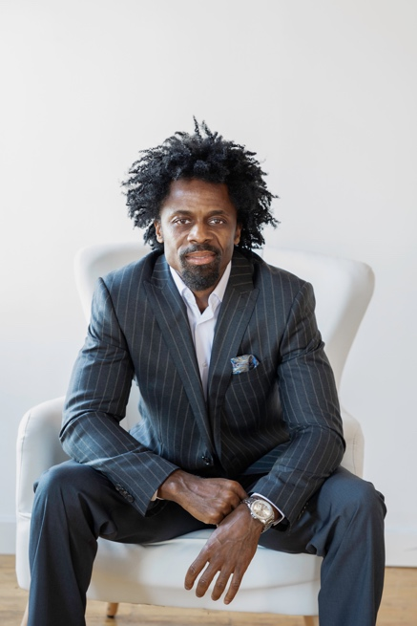

Developer, Educator, Entrepreneur, Visionary

Tyrone Minor is the founder and CEO of The Mali Center, a holistic wellness empowering health and diverse entrepreneurship in the North End and surrounding communities of St. Paul, Minnesota. Tyrone's leadership at The Mali Center leverages his extensive network of diverse business owners, community partners, and nonprofit organizations to drive the company's growth strategy. Under his guidance, The Mali Center has become a thriving hub for health and wealth, promoting equitable access and opportunities for women and entrepreneurs of color.

Tyrone's entrepreneurial journey is rooted in his experiences growing up in historic Rondo. He has successfully established and scaled multiple businesses, including TMREIT, LLC, a CERT and S/MBE certified real estate development company, Chizel, Inc., an elite personal training business and The F.I.T. Lab, an anchor member of The Mali Center ecosystem.

Tyrone is certified personal trainer, and licensed educator with over 25 years of experience in business, fitness and education.

